Cow-A-Bunga Flavors
(Glacier Homemade Ice Cream)

We carry 24 flavors at all times! We rotate between the flavors listed below and a few our seasonal flavors!

** Gluten Free Regular Flavors *** Dairy Free
**Raspberry Chip Cookie & Cream ***Raspberry Sorbet
**Peanut Butter Chocolate Pink Cadillac ***Mango Sorbet
**Vanilla Cookie Jar ***Valrona Chocolate
**Chocolate Snickers ***Passion Fruit Sorbet
**Turtle Death By Chocolate
**Chai Key Lime Pie * Seasonal
**Butter Pecan Pralines & Cream *Peppermint Stick
**Rootbeer Float Birthday Cake *Vermont Honey Maple
**Cappuccino Chip 3 Nut Rocky Road *Pumpkin
**Salted Butterscotch Cow-A-Bunga * Pistachio
**Bing Cherry Coffee Caramel Crunch*Colorado Peach
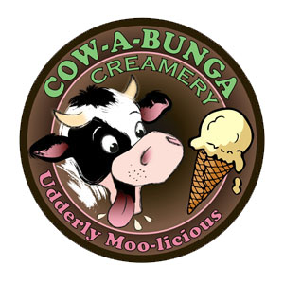
Peanut Butter Blast *Eggnog
Funky Donkey
Salted Caramel Oreo
Cookie Dough

